Retail Store Sales Forecasting

# Name

John Otieno

[https://github.com/dvhub7/Capstone](https://github.com/dvhub7/Capstone/commit/3ddc6af02474ad2bbe59b1f8a13b8cd32e7471fb)

# Project Abstract

One challenge of modeling retail data is the need to make decisions based on limited history. Sales forecasting is crucial for many retail operations. It is not easy for large retailers to understand the market conditions of stores in different geographical locations. Based on that prediction, resources can be allocated so business can reduce loss and generate large profits.

In this research, the goal is to forecast weekly sales of 45 Walmart stores in different geographical locations each having multiple departments. The goal is to project the sales of each department in each store using the historical data.

# Introduction

Forecasting on sales is one of the most important task of every business. I would like to analyze how internal and external factors of one of the largest retail companies can affect their Weekly Sales in the future. This project tries to achieve an approximate weekly sales prediction looking at the previous years performance per Store on a weekly basis. The number of stores are 45 with multiple departments within them and they are spread across the country.

Problem I am trying to solve:

How well can weekly sales be forecast for each department in each store?

Predicting the department wide sales for each store. I will be using R for preprocessing of the data and building further models. I am also hoping to adopt ARIMA and Regression time series analysis for predictive modelling. ARIMA is a popular method of modeling time series, because of it’s flexibility and generalizability.

**Literature Review**

There are a couple of different categories of literature that need to be reviewed to ensure best practice for the project. These are set out systematically below.

**Literature About Time Series Modelling**

A time series is just collection of past values of the variable being predicted. It basically working on time (years, days, hours, and minutes) Also known as naïve methods. Goal is to isolate patterns in past data, to explore hidden insights of the data and trying to understand the unpredictable nature of the market which we have been attempting to quantify.

* Literature review of modern time series forecasting methods.

http://individual.utoronto.ca/paulkara/S2012%20Literature%20Review%20-%20linear%20survey.July31.pdf

**Literature About Machine Learning**

This is a good first step for someone looking to learn the steps needed for exploring data, cleaning data, and training/evaluating some basic machine learning algorithms. It is also a useful resource for someone who is comfortable doing data science in other languages and wants to learn how to apply their data science skills in R.

* https://www.kaggle.com/camnugent/introduction-to-machine-learning-in-r-tutorial/notebook

**Literature About Predictive Modelling**

* A Novel Trigger Model for Sales Prediction with Data Mining Techniques

Authors: Wenjie Huang, Qing Zhang, Wei Xu, Hongjiao Fu, Mingming Wang, Xun Liang

**Literature About Forecasting**

The predictability of an event or a quantity depends on several factors including:

1. how well we understand the factors that contribute to it;
2. how much data are available;
3. whether the forecasts can affect the thing we are trying to forecast.

* Forecasting: Principles and Practice *Rob J Hyndman*, *George Athanasopoulos (Book)*

This textbook is intended to provide a comprehensive introduction to forecasting methods and to present enough information about each method for readers to be able to use them sensibly.

# Dataset

In this experiment, we use Walmart’s open dataset from kaggle (link:<https://www.kaggle.com/c/walmartrecruiting-store-sales-forecasting/data>). Multiple data sets are provided in the link above but all we use are three datasets named train.csv, store.csv, features.csv.

**Stores.csv**:  
- Store: The store number. Range from 1-45.  
- Type: Three types of stores ‘A’, ‘B’ or ‘C’.  
- Size: Sets the size of a Store would be calculated by the no. of products available in the particular store ranging from 34,000 to 210,000.

**Train.csv**: **421570 records**  
- Date: The date of the week where this observation was taken . - Weekly_Sales: The sales recorded during that Week. Weekly sales for the given department in the given store from Feb 5, 2010 to Nov 1, 2012. - Store: The store which observation in recorded 1-45.  
- Dept: One of 1-99 that shows the department.  
- IsHoliday: Boolean value representing a holiday week or not. Whether the week is a special holiday week.

-The data contained 421,570 rows, with some store-specific departments missing a few to many weeks of sales.

**Features.csv**: **8190 records** - Temperature:Temperature of the region during that week.  
- Fuel_Price: Fuel Price in that region during that week.  
- MarkDown1:5 : Represents the Type of markdown and what quantity was available during that week.  
- CPI: Consumer Price Index during that week.  
- Unemployment: The unemployment rate during that week in the region of the store.

**Test.csv: 115064 records** Data from this file has the same fields as the Train data, only the Weekly_Sales are empty.

# Approach

All steps of this analysis have been brought together at this location

Github link: https://github.com/dvhub7/Capstone/blob/master/sales_forecast_v3.html

Data Exploration: Went over the provided datasets using R in detail to give an in-depth explanation of each dataset.

## Step 1: Load Data/Data collection

Details:

Downloaded the data sets from the kaggle website. Stored it on the google shared drive. The data sets collected from the kaggle website include Train.csv, Test.csv, Stores.csv and Features.csv. The competition is called Walmart- recruiting store sales forecasting and can be found using the link below.

<https://www.kaggle.com/c/walmart-recruiting-store-sales-forecasting>

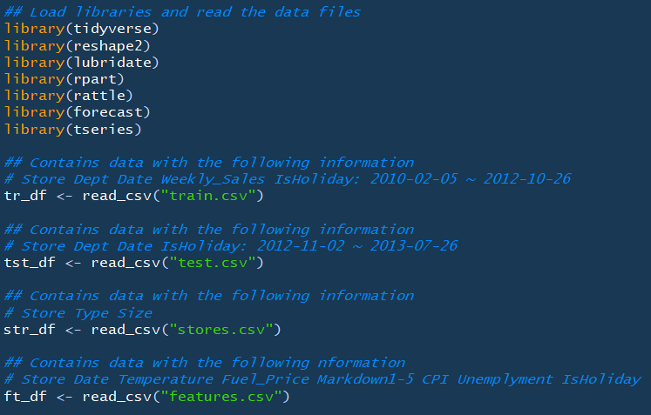

## Step 2: Data cleaning/structuring

Details:

Collecting and preparing the data for analysis are often the most involved and time consuming parts of building a predictive model. While the collection was done for us, we still have to do a bit of work to prepare the data.

Change some feature types to factors for better anaylsis of the data. This was done for both the training and the test data sets.

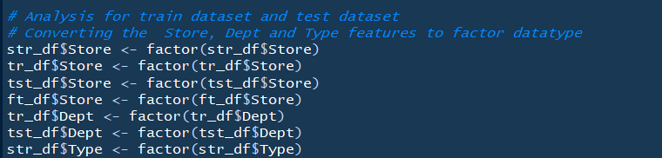

Merge the data frames "train", "Feature" and store" using the variable "store".

Identify all the rows without missing data and use them for the dataset.

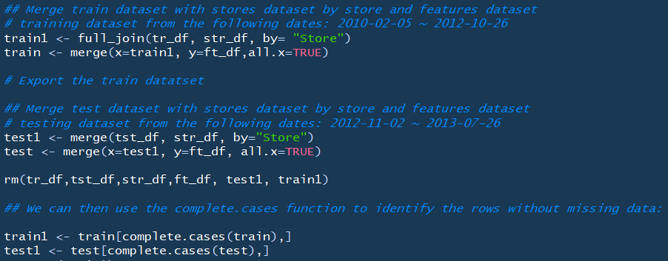

Find the columns with the missing values

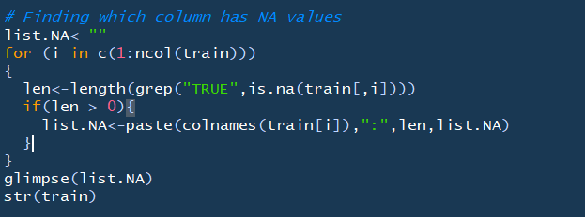

Visualize the features of the data sets to better understand the data. I used the histogram for the numerical features

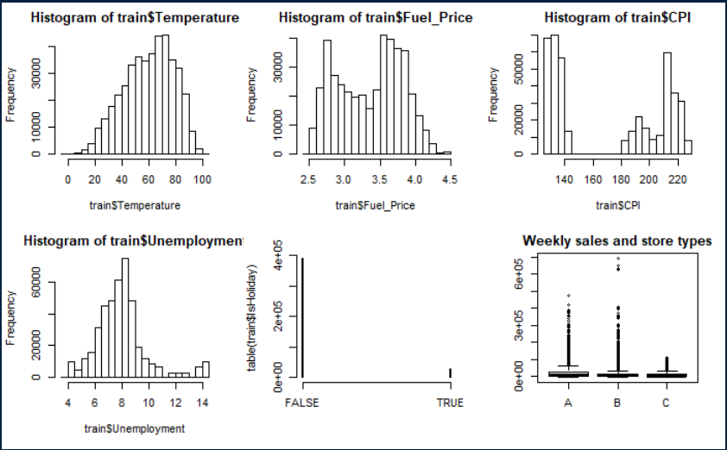

## Step 3: Exploratory data analysis

Details:

* Explore relationships in the data, such as sub-questions to examine:
  + Visualizing and compare the sales of different Departments across the same store to look for similarities or differences throughout the year.
  + 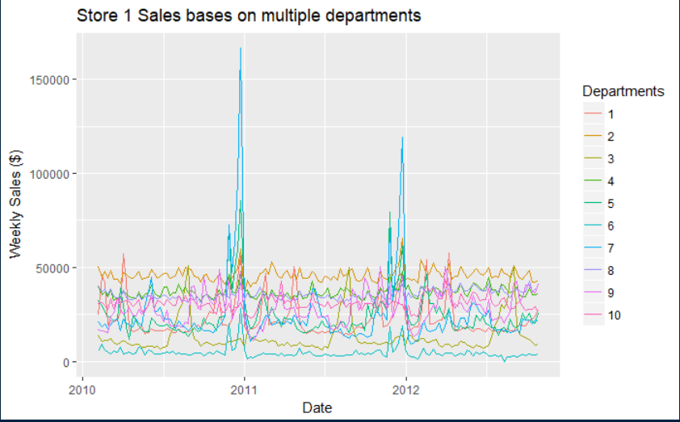
  + Visualizing a graph that will compare same department across different stores
  + 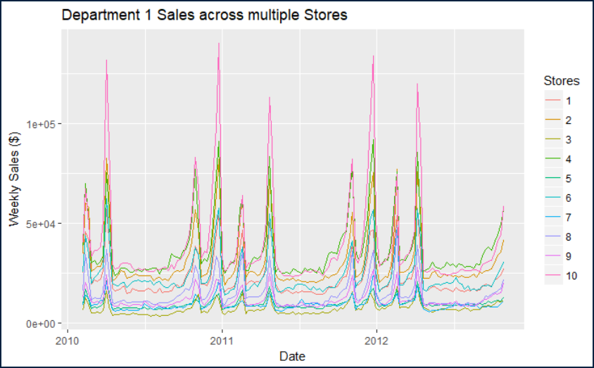
* Compare the weekly sales by stores to see how the stores are performing within there locations

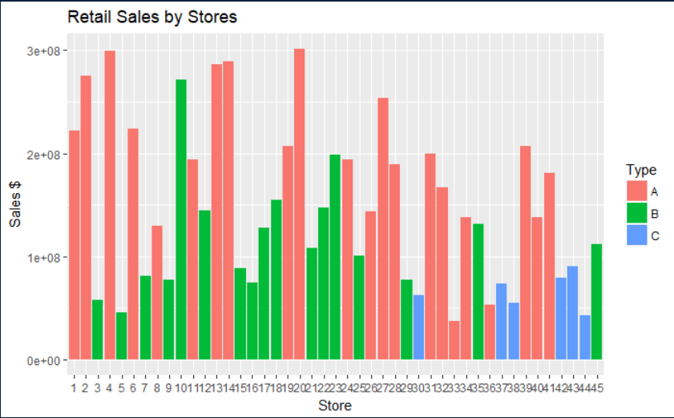

THINGS TO DO:

I need to review the times series regression to see how it will be able to answer my research question:

How well can weekly sales be forecast for each department in each store?

Another option is to look into utilizing the OLS regression as well as the ARIMA model.

There are two main goals of time series analysis: (a) identifying the nature of the phenomenon represented by the sequence of observations, and (b) forecasting (predicting future values of the time series variable). Both of these goals require that the pattern of observed time series data is identified and more or less formally described. ARIMA is a complex technique; it is not easy to use, it requires a great deal of experience, and although it often produces satisfactory results, those results depend on the researcher's level of expertise (Bails & Peppers, 1982).

**Bibliography**

[1] A Novel Trigger Model for Sales Prediction with Data Mining Techniques

Authors: Wenjie Huang , Qing Zhang, Wei Xu, Hongjiao Fu, Mingming Wang, Xun Liang

[2] Forecasting: Principles and Practice *Rob J Hyndman*, *George Athanasopoulos (Book)*

[3] Business fluctuations: Forecasting techniques and applications.

Authors: Dale Bnails, Larry C. Peppers

[4] Souhaib Ben Taieb, James W Taylor, Rob J Hyndman (2017) Coherent Probabilistic Forecasts for Hierarchical Time Series.

[5] T.-M. Choi, Y. Yu, K.-F. Au, A hybrid SARIMA wavelet transform method for sales forecasting, Decision Support Systems, (51) (2011), pp. 130-140.

[6] Kaggle competition participants from the Kaggle Competition

[www.kaggle.com/c/walmart-recruiting-store-sales-forecasting](http://www.kaggle.com/c/walmart-recruiting-store-sales-forecasting)

[7] Kaggle Walmart recruiting store sales forecasting competition discussion board.

[8] Several youtube videos and blogs about Forecasting and time series analysis

[9] Linear Regression with time series data Author Heino Bohn Nielsen http://www.econ.ku.dk/metrics/Econometrics2_05_II/LectureNotes/regression.pdf